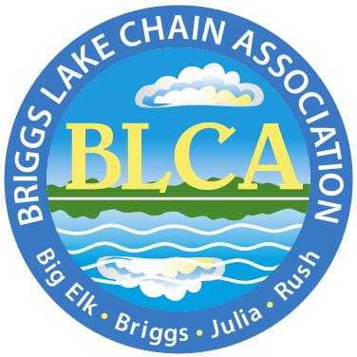
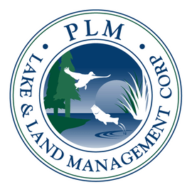
PLM Lake and Land Management Corp.
Midwest Region
Tel. 1-866-687-5253
Office. 1-218-270-3338

SUBJECT: BLCA 2025 Individual Aquatic Plant Management

Dear BLCA Property Owner,

We at PLM Lake and Land Management Corp. hope this message finds you well, that you had an enjoyable season at the lake in 2024, and are starting to prepare for the 2025 season.

The BLCA is pleased to announce that they will again be using PLM for shoreline aquatic plant control in 2025. PLM is offering a one or two treatment program for individual shoreline management during the summer. The first treatment is expected to occur in early June and the second follows approximately four to six weeks after.

PLM Lake and Land Management Corp. is offering a reduced price to BLCA property owners. PLM will also pay for your $35.00 MN DNR permit in 2025 for new customers.

- Pricing Information:
  - BLCA Price - $5.60 Per Foot along shore, Per Treatment
  - You may request to treat half of your shoreline owned up to 100’, whichever is less, and up to 100’ lakeward.
  - All customers will be assessed a $5.00 fuel surcharge
  - Pricing Example: You own 100’ of shoreline, so you request to treat 50’ along shore, 100’ lakeward, and you chose to have two treatments:
    - 50’ x $5.60 = $280.00 x 2 treatments = $560.00
    - add $5.00 fuel surcharge = $565.00 Season Total
- Provided Documents:
  - 2025 New Customer Form and Map
    - Please review the requested fields on the blank form and complete in its entirety.
    - Please remember to draw a general sketch of where you prefer treatment at your lakefront property.
- Other Notes:
  - Final approved area will be determined by the DNR and an issued permit.
  - Upon receiving your New Customer Form, PLM will send you a One Year Service Agreement, which we will need signed and returned with payment by our due date of April 15th to help ensure a timely and valid MN DNR permit.
  - For any special treatment requests, or questions about sizing/locations/weeds treated, please call our office.

We at PLM Lake and Land Management Corp. look forward to the opportunity to work with you and please do not hesitate to contact us with any questions or concerns.

Sincerely,

PLM Lake and Land Management Corp.
Midwest Region
218-270-3338
mnadmin@plmcorp.net

